Help and support for CBO Mobile Reporting Application

CBO Mobile Reporting

**For** **Xiaomi Device**

***1)Autostart Permission***

1. Open the ***Settings***  on your Xiaomi device. 2. Tap **Permissions**.  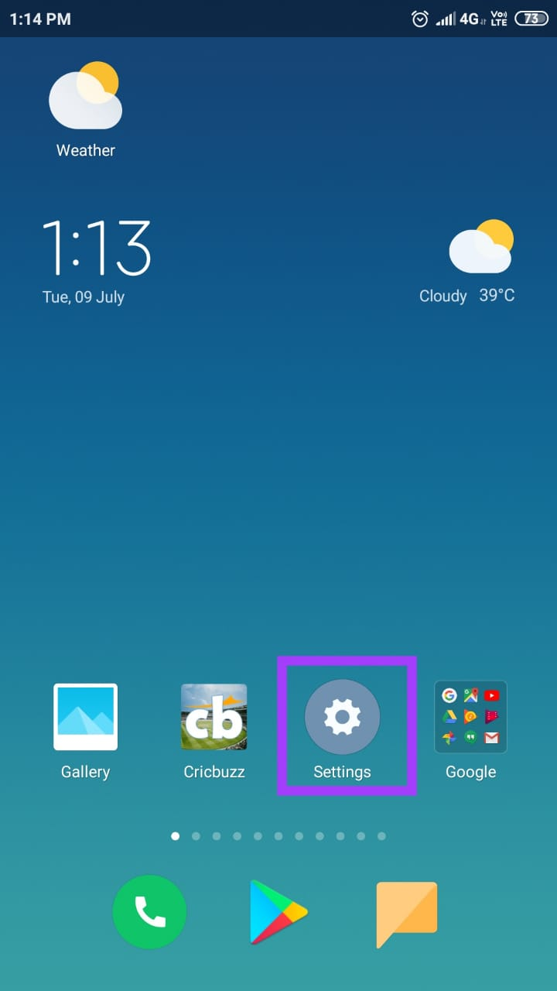 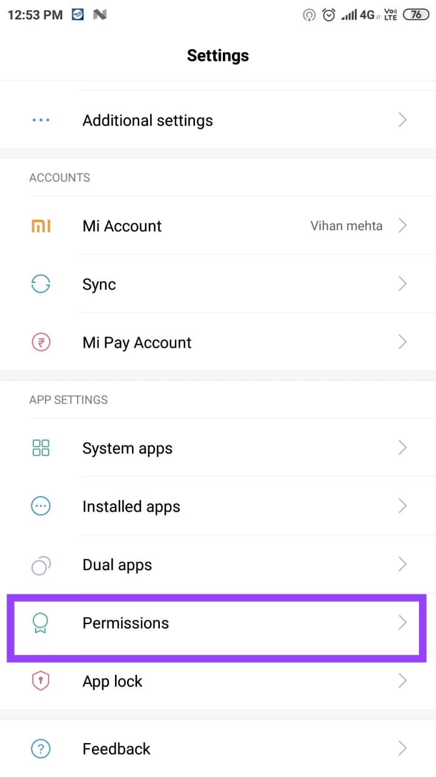

3. Tap ***Autostart***. 4. Swipe to enable **Autostart** for ***Nine***.

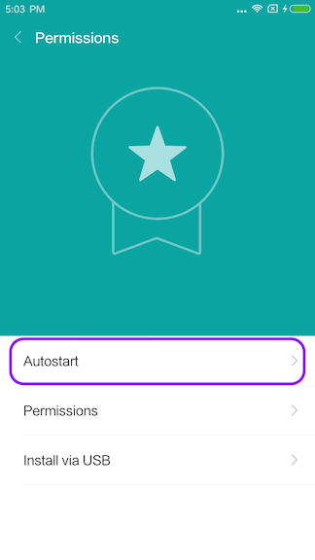 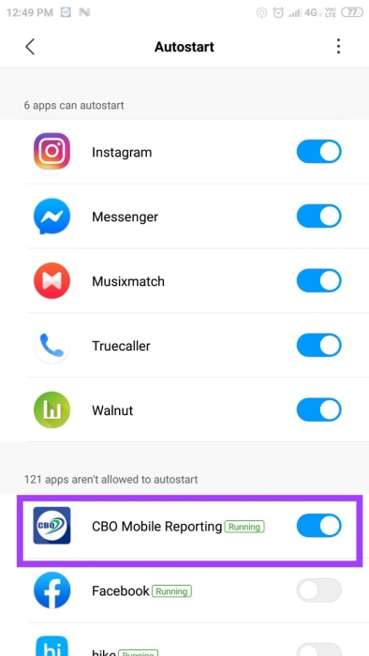

**2)Whitlist CBO to Run On BackkGround**

1) Open the ***Security***  menu on your Xiaomi device 2. Tap **Battery & performance**from ***Settings.***

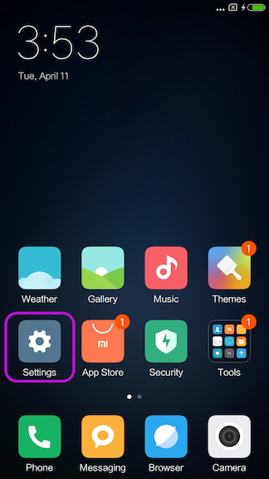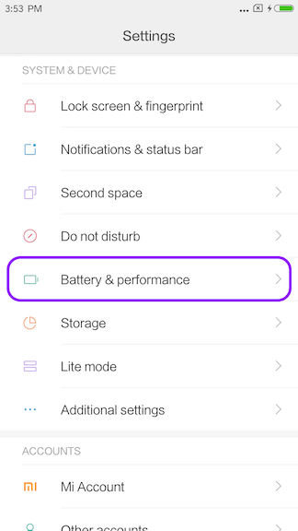

3. Tap **Choose apps**from ***Manage apps' better usage*** 4.Select **Cbo Mobile App** From App List

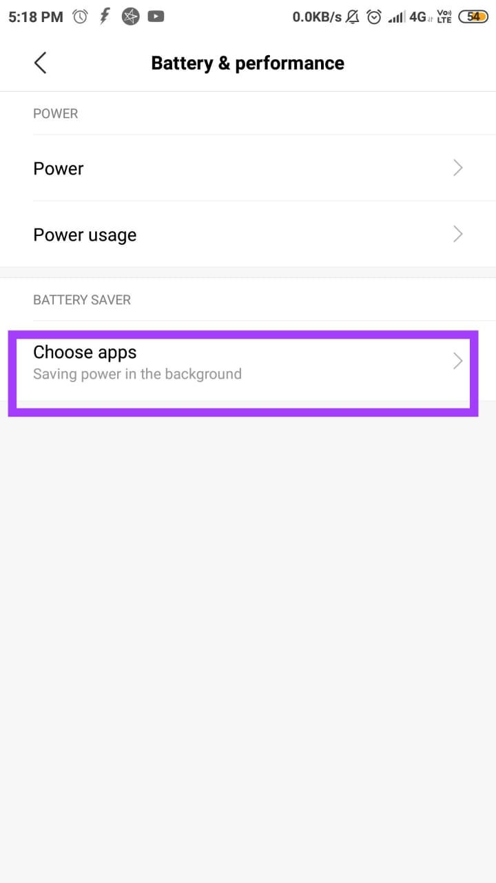 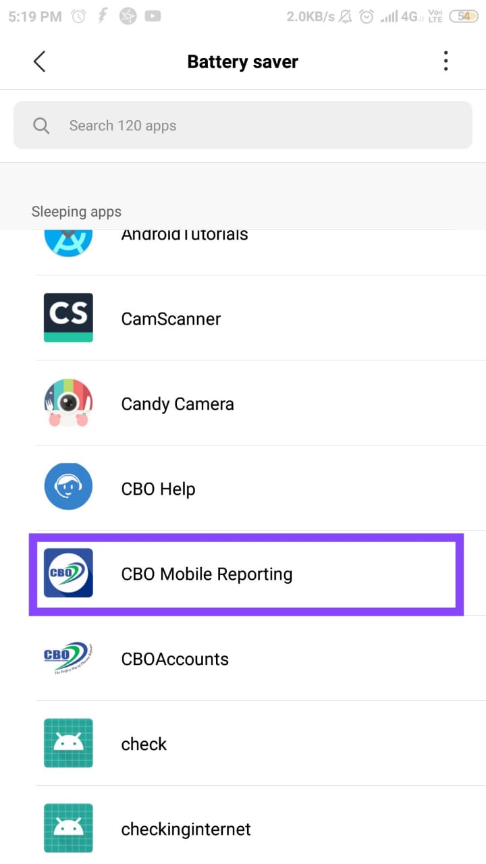

5. Tap ***No restrictions***. Please note that **Cbo Mobile App** is no longer affected from ***Doze feature***

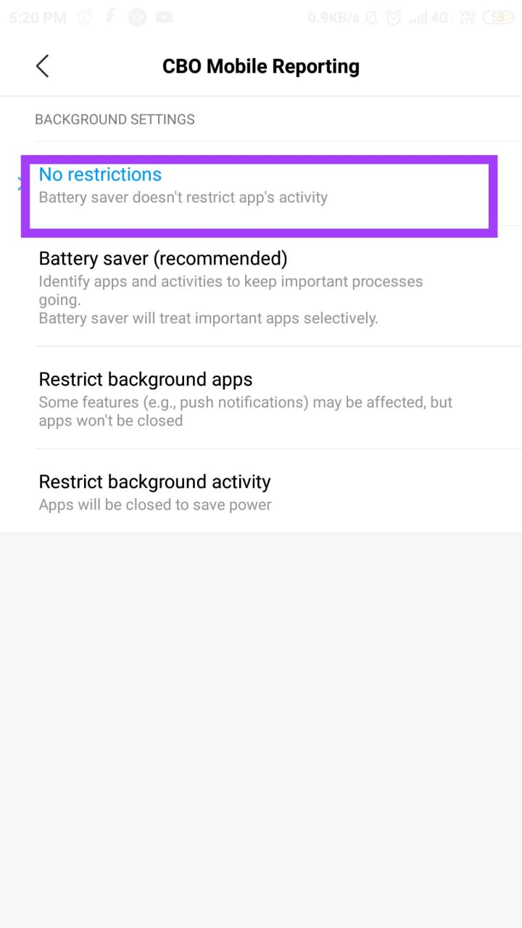

fghgh

**For** **Vivo Device**

For Funtouch OS**2.6 and lower version**: Go to i Manager>App manager**>Autostart manager**to turn on/off the app switch.

**Step 1:** Open **iManager app** which comes pre-installed on Vivo device. If you are not able to find the iManager app on your home screen, **search for it.**

**Step 2:** Go to **App Manager**

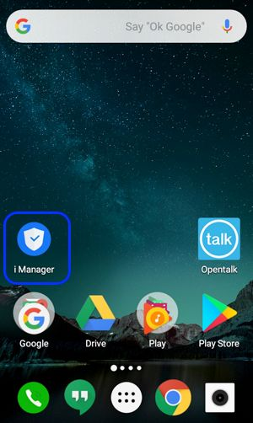 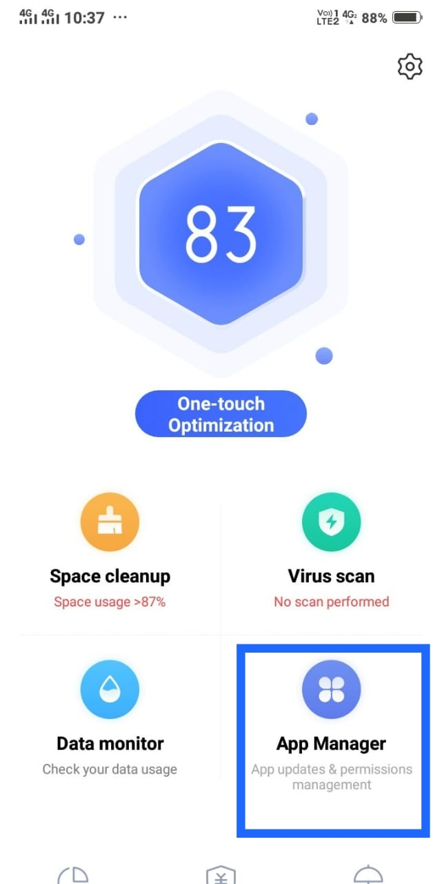

**Step 3:** Select **Permission Managment**  **Step 4:** Select **AutoStart**

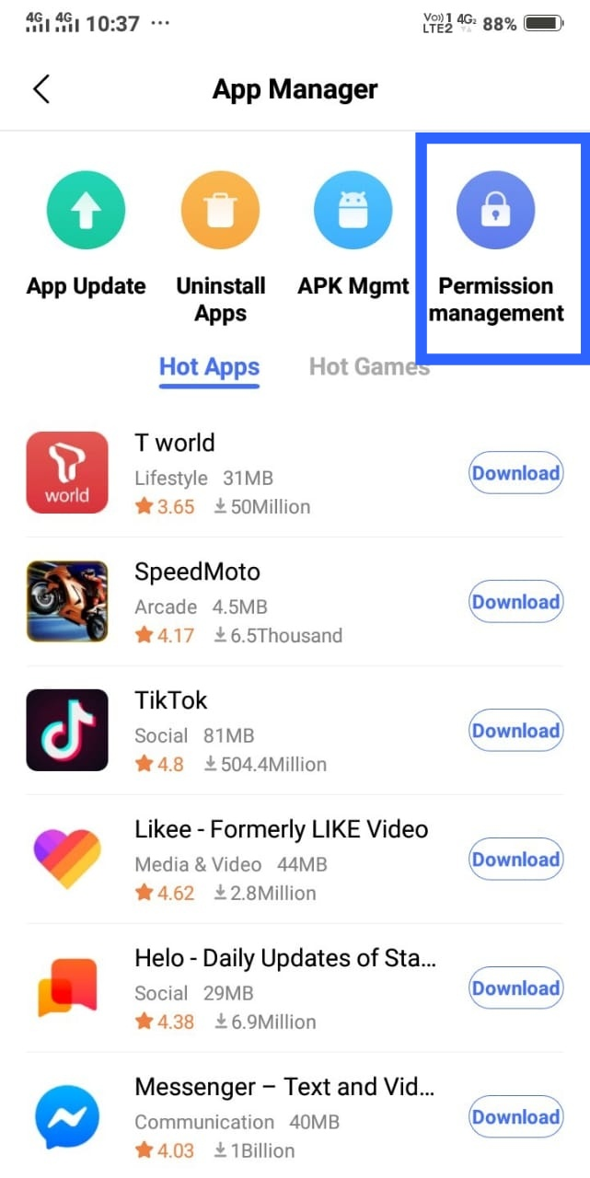 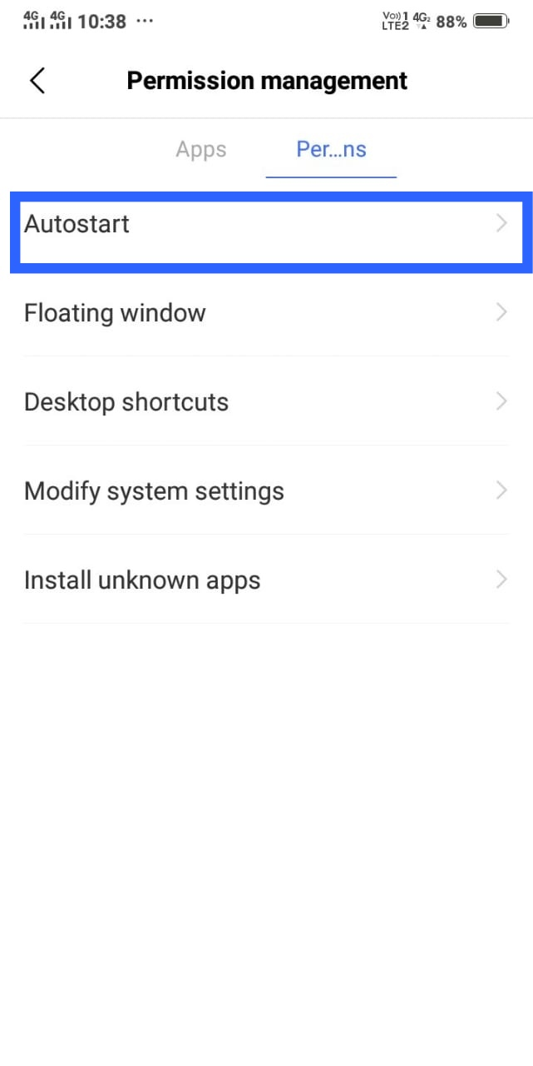

Step 5: Enable **Autostart** for **CBO MobileReporting** app

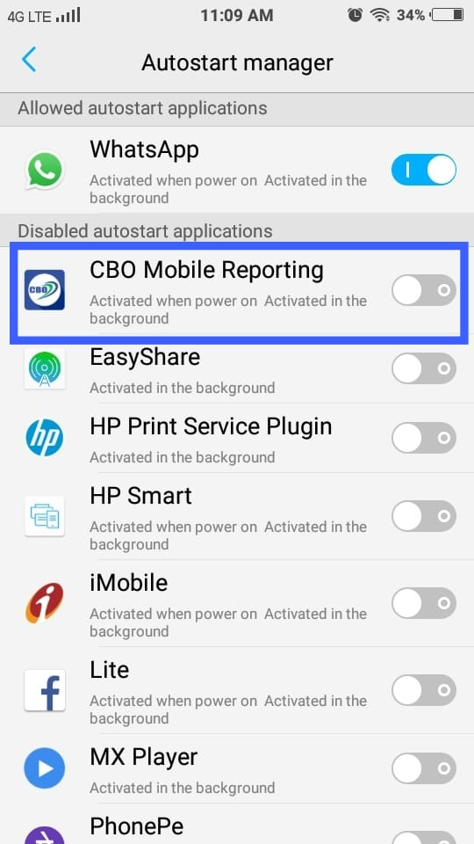

For above Funtouch OS**2.6 version**:

Step 1. Open the ***Settings***  on your **VIVO Device** Step 2: Select **More Settings**

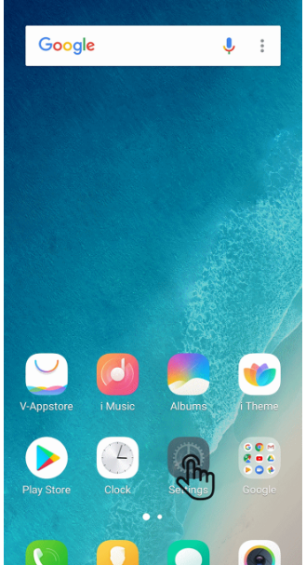 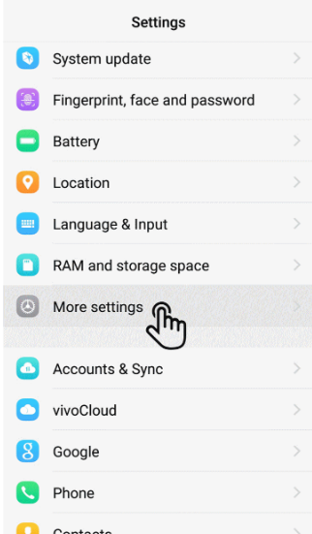

Step 3:Select **Application** From More Settings Step 4:Select **Application** From

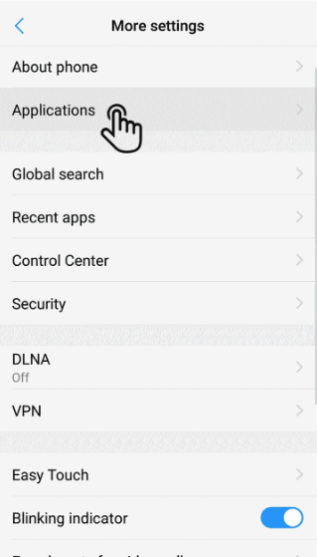 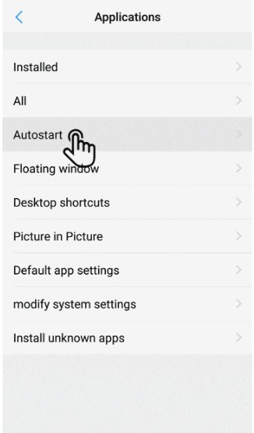

Step 5: Enable **Autostart** for **CBO MobileReporting** app



**For** **Oppo Device**

Step 1: Open "Security Center" app which comes pre-installed on Oppo device. If you are not able to find the "Security Center" app on your home screen, search for it.

Step 2: Go to "PrivacyPermissions"

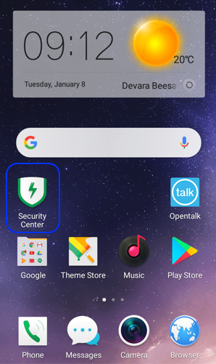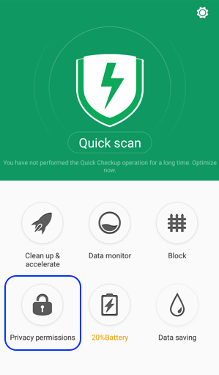

Step 3: Select "Startup Manager" Step 4: Enable Autostart for Cbo app

